COP3503 Homework 01 05-13-2014

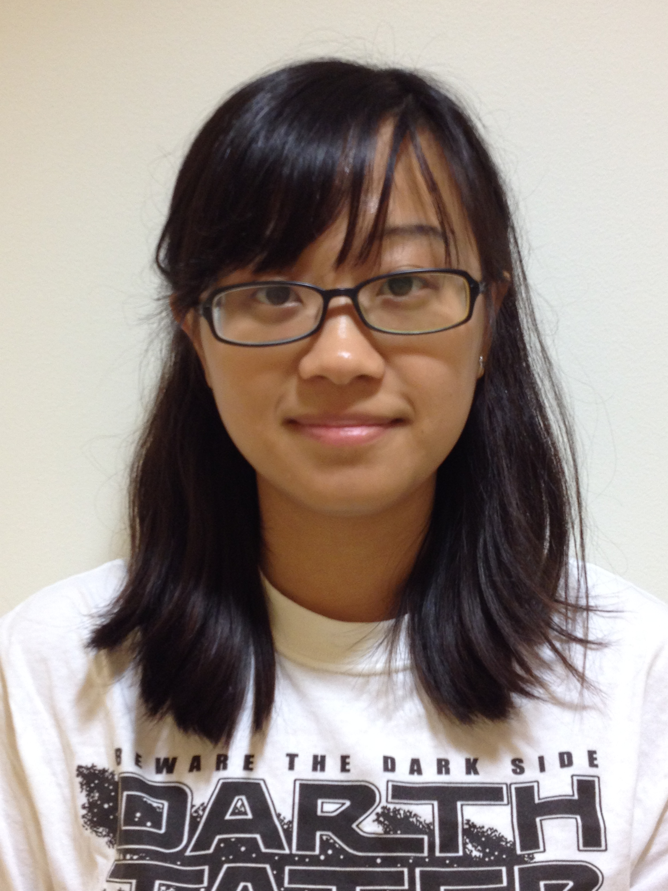

Wenlan Tian

“Wenlan”

[tianwenl@ufl.edu](mailto:tianwenl@ufl.edu) (Ok to share☺)

Major: Environmental horticulture, 4th year PhD

**Experience with computing and programming**

I learned basic data structures through public online courses, but I have very rare programming experience. I only used some unix commands for my research and learned java language by myself for couple months. It’s really hard to learn programming on my own, thus I’m taking this class.

**Hope for this class**

(1) Acquire programming skills in C++.

(2) Be familiar with computer science, and get used to think in computational terms

**About myself**

I came from China. I have been in United States for about 4 years since 2010. I usually go to Zumba and hiphop fitness classes when I have time. I love travelling. My next destination would be South America.